**E-Commerce App MVP Proposal**

Data structure → JSON files

Items:

{

"name": "Casio G Shock Watch Solar Atom (gwm500a-1)",

"price": "$67.62",

"body_location": "Wrist",

"category": "Lifestyle",

"_id": 6546,

"imageSrc":

"numInStock": 9,

"companyId": 19962

}

{

"name": "Polar H1/H2 Heart Rate Transmitter Soft Strap: XS/SM",

"price": "$16.95",

"body_location": "Chest",

"category": "Medical",

"_id": 6944,

"imageSrc":

"numInStock": 6,

"companyId": 11837

},

Companies:

| { |  |
| --- | --- |
|  | "name": "Bowflex", |
|  | "url": "http://www.bowflex.com/", |
|  | "country": "United States", |
|  | "_id": 11385 |
|  | }, |

**1-** **Homepage:**

1.1 NavBar:

· App Logo

· Search Bar (stretch)

· Login Btn (stretch)

· Sign Up Button (stretch)

· Cart Icon

1.2 Announcement Space → for the admin to display adds or sales (stretch)

**2** **Product Page → When clicking on a product**

2.1 Product details (e.g. price, qty, etc.)

· Add to cart btn

2.2 cart notifs of amount of items (stretch goal)

2.3 sort by category (medical, fitness, lifestyle, entertainment, industrial, pets and animals… (stretch goal)

2.4 number of items on the page (stretch goal)

**3** **Cart Btn**

Guest Checkout → 4

Create an account → 5

view cart (see the total amount)

for each item, edit quantities

clear the cart (stretch goal)

Pay - send data to server

review confirmation page (stretch goal)

**4** **Guest Checkout Page - (stretch)**

**5** **Create an Account Page - (stretch)**

**See below for an organized chart**

**MVP Chart With Stretch Goals**

**Mandatory category is the basic requirements to pass the project!**

Feel free to add all the other ideas in the stretch goals category, for now let’s focus on the [MVP](https://github.com/flcheng/project-GROUP-e-commerce/blob/master/__documentation/PROJECT.md) required to pass :)

| **Home** |  |
| --- | --- |
| **Mandatory** | **Stretch** |
| * Navigation Bar (App Logo, Cart Icon, Product Page) * Add a random lifestyle image as background (so the page isn’t just the navigation bar) | * Search Bar (Nav) * Login/Sign Up Button (Nav) * Announcement of products and sales |
| **Products Page List** |  |
| **Mandatory** | **Stretch** |
| * List all items (preferably alphabetical order, with price) * Link items to detailed product page | * Sort by category, body location, company or price) * Paginate pages |
| **Detail Product** |  |
| **Mandatory** | **Stretch** |
| * Larger view of selected item, with the price and the company name. * Buy button * Qty in stock displayed | * Select the amount desired to purchase item * Customers can view the quantities left for a product * Adding recommendation of products from the same category under the product information |
| **Cart Page** |  |
| **Mandatory** | **Stretch** |
| * View Cart * Editing items (adding / reducing quantities and delete item off of cart * Buy Button (sending data to server) | * Viewing total cost * Viewing the cost of 1 item * Enter customer info (first name/ last name) * Clear cart * Confirmation Page of purchase (like a receipt?) * Check out as a guest/ sign in - which requires information text input fields |

[**Figma Wireframe/ Design**](https://www.figma.com/file/HmPOblpCFOkRp7FYhJLSUF/Ecom-Project---Team-5?node-id=2%3A25)

[Images from the design](https://drive.google.com/drive/folders/1joQFmHAZDI_ZrcYv6UttW_3aXCaDDuMl?usp=sharing)

[Font Oswald](https://fonts.google.com/specimen/Oswald)

[Font Roboto](https://fonts.google.com/specimen/Roboto?query=roboto)

To view the pages, on the top left corner you will see the different options.

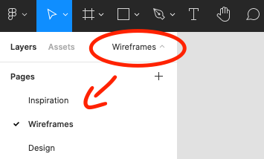

Please leave notes or comments by using this bubble in the toolbar!

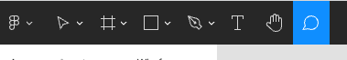

To view the flow of each page, on the top right corner, select prototype.

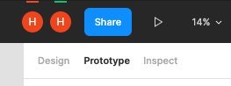

View design full screen, select the page you want to view and click on play button

